**ASSIGNMENT-3**

Create and design a social media advertisement poster using Canva.

|  |  |
| --- | --- |
| NAME | S.SASIKUMAR |
| NM ID | E743439B51D3AC28ED844AA6B74B483E |
| ASSIGNMENT 3 | Create and design a social media advertisement poster using Canva |

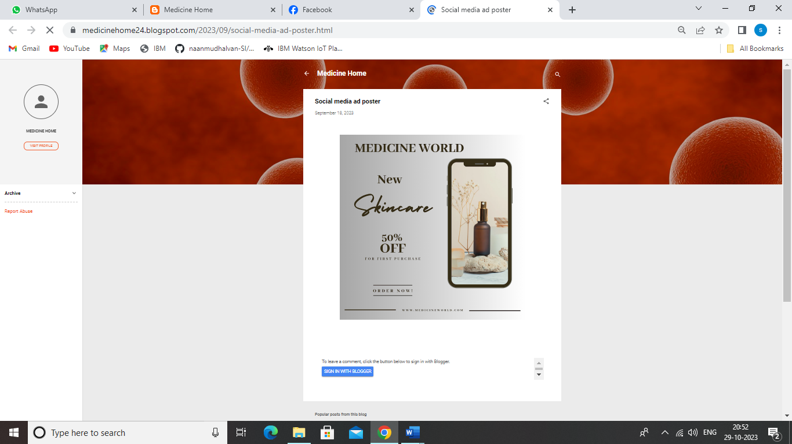

**SOCIAL MEDIA AD POSTER LINK:**

**<https://medicinehome24.blogspot.com/2023/09/social-media-ad-poster.html>**